**INTI International College Penang School of Engineering and Technology**

**3+0 Bachelor of Science (Hons) in Computer Science, in collaboration with Coventry University, UK**

**3+0 Bachelor of Science (Hons) in Computing, in collaboration with Coventry University, UK**

**Coursework cover sheet**

**Section A - To be completed by the student**

|  |  |
| --- | --- |
| Full Name: Ko Chi Ling | |
| CU Student ID Number: P21013435 | |
| Semester: 1 | |
| Session:  **August 2022** | |
| Lecturer:  **Nadhrah Abdul Hadi (nadhrah.abdulhadi@newinti.edu.my)** | |
| Module Code and Title:  **4067CEM Software Design** | |
| Assignment No. / Title:  **Continuous Assessment** | % of Module Mark:  **50** |
| Hand out Date:  **6th September 2022** | Due Date:  **Task 1: 30 September 2022, by 11.59pm.**  **Task 2: 18 November 2022, by 11.59pm**  **Task 3: 4 November 2022, by 11.59pm.**  **Task 4: 4 November 2022, by 11.59pm.**  **Task 5: 4 November 2022, by 11.59pm.** |
| Penalties: No late work will be accepted. If you are unable to submit coursework on time due to extenuating circumstances, you may be eligible for an extension. Please consult the lecturer. | |
| Declaration: I/we the undersigned confirm that I/we have read and agree to abide by the University regulations on plagiarism and cheating and Faculty coursework policies and procedures. I/we confirm that this piece of work is my/our own. I/we consent to appropriate storage of our work for plagiarism checking.  Signature(s): ________________________ | |

Task 1

**College buddy system for student**

**Goals of the buddy system**

The goals of the buddy system are to help the student to make new friends. As the student are shy to make friend with others, buddy system is a good system like matching two person that have the same personalities and interest to meet each other. The goal of the buddy system is can help student to find a study partners or a senior that are same program with the student to improve their academic results. Some students need a study partner to help them in their studies so that the students can learn more new knowledge from their partners.

**User of the buddy system**

The user of the buddy system is student that want to make new friend. The user of the buddy system is the one who want a study partner to share and gain knowledge together.

**Values and benefits**

The benefits of using this college buddy system for student is increase the chance for the student to communicate with each other and make more friend. The benefit of using this college buddy system is to help the students to improve their academic results. The benefit of using this college buddy system is to improve the student language skills by chatting with buddy. This is because the buddy can always correct the student if the student has made any mistake like grammar error.

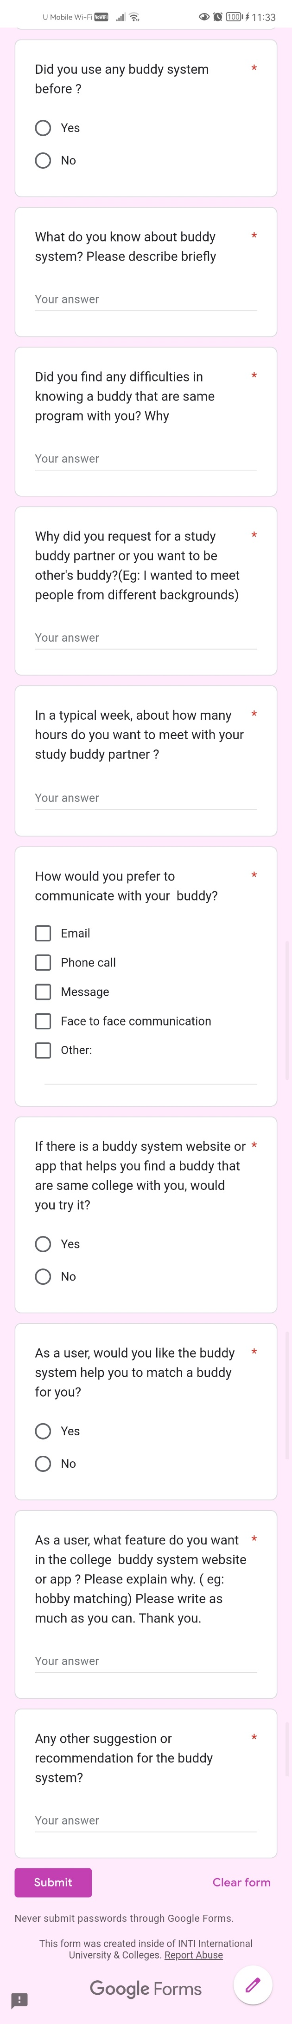**Google Form Survey Question**

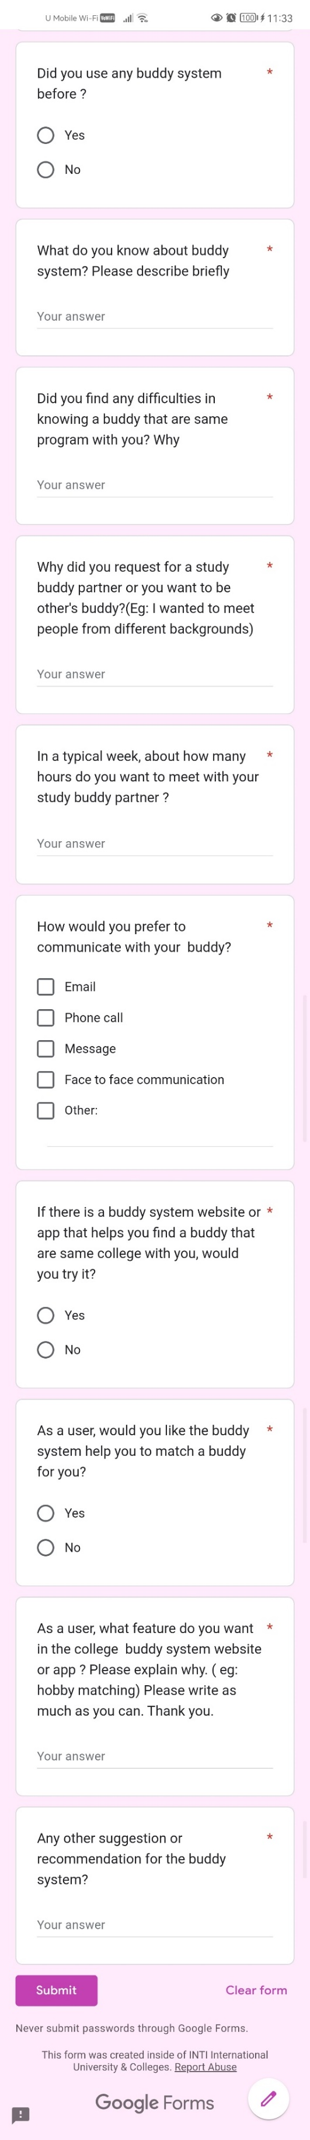

**Google Form Survey Answer**

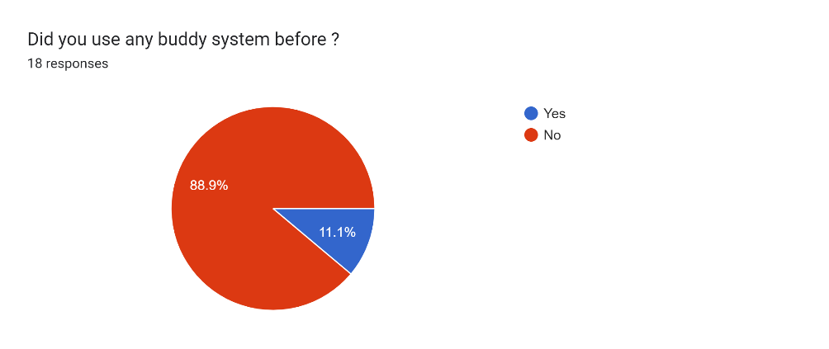

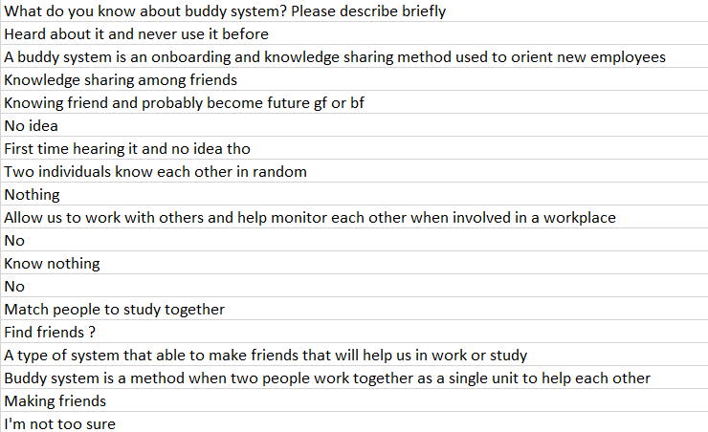

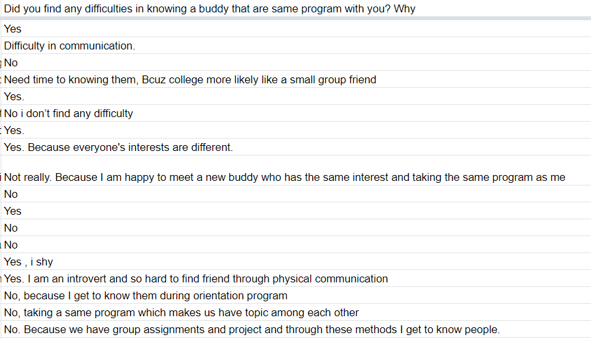

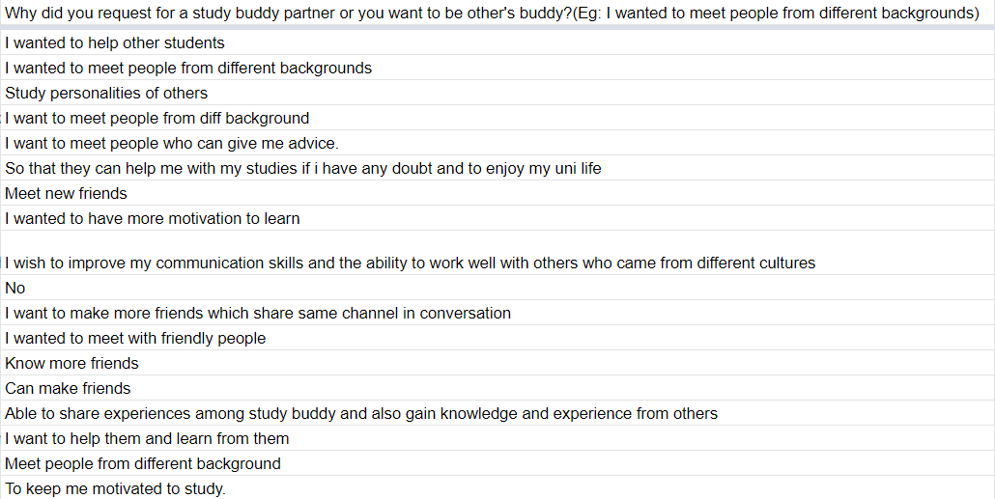

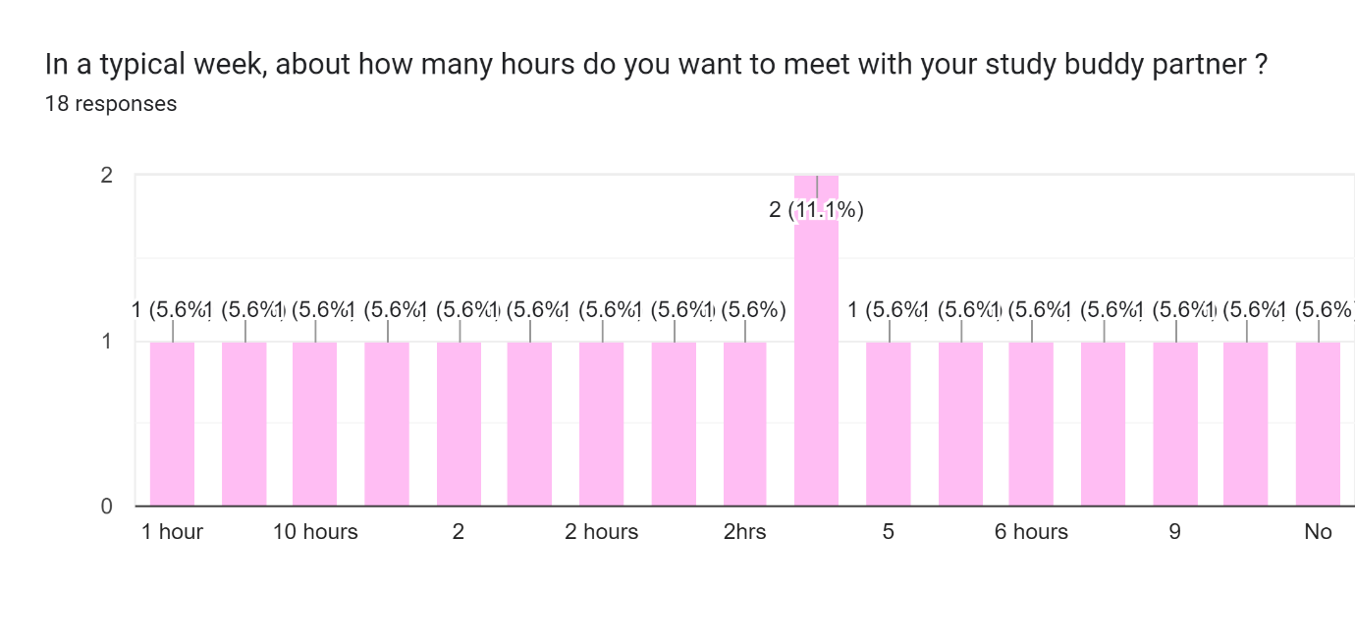

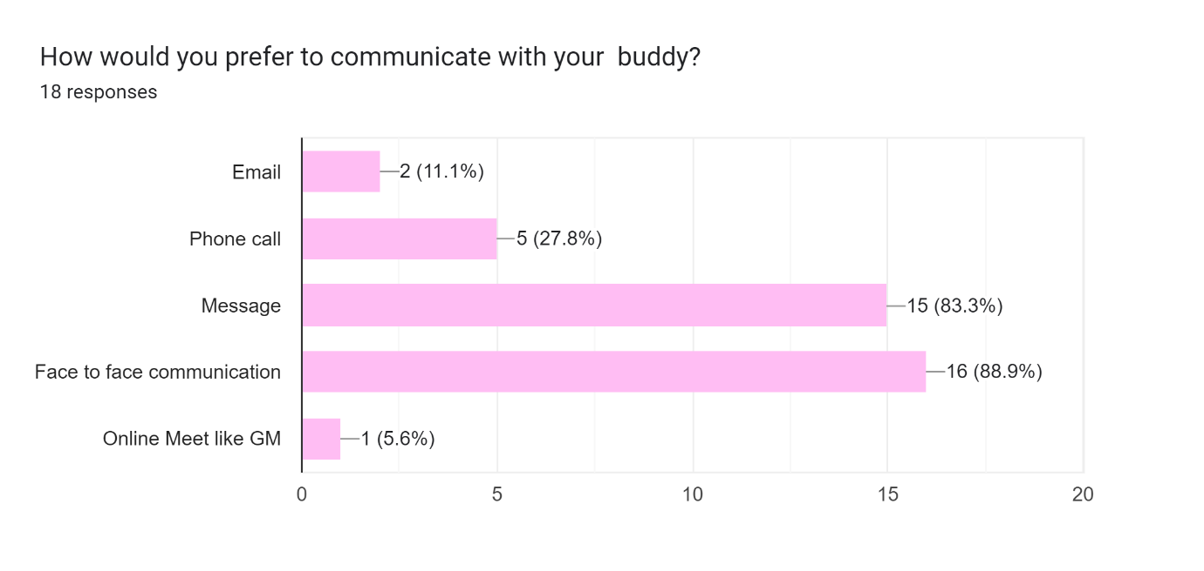

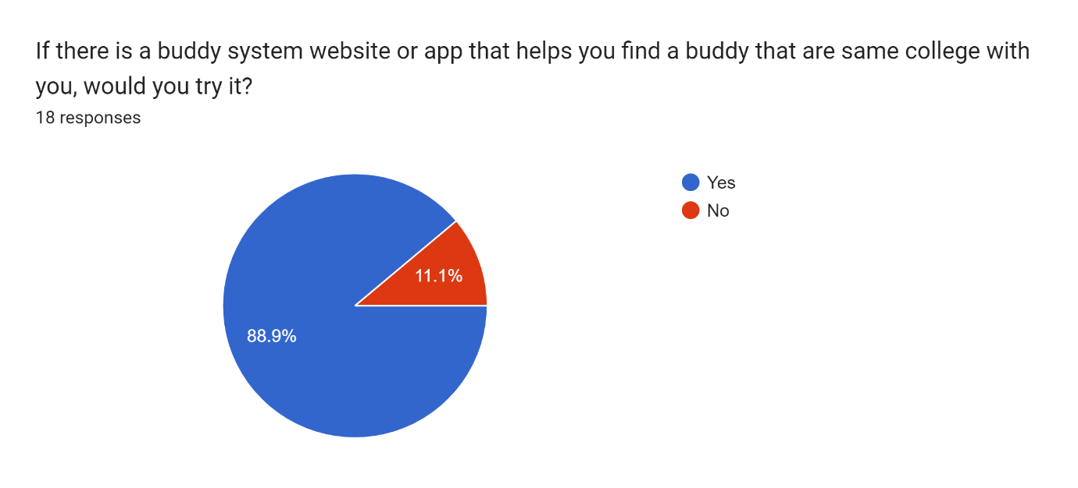

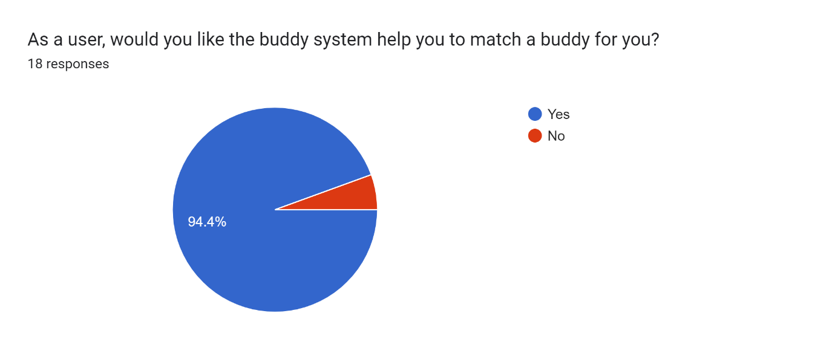

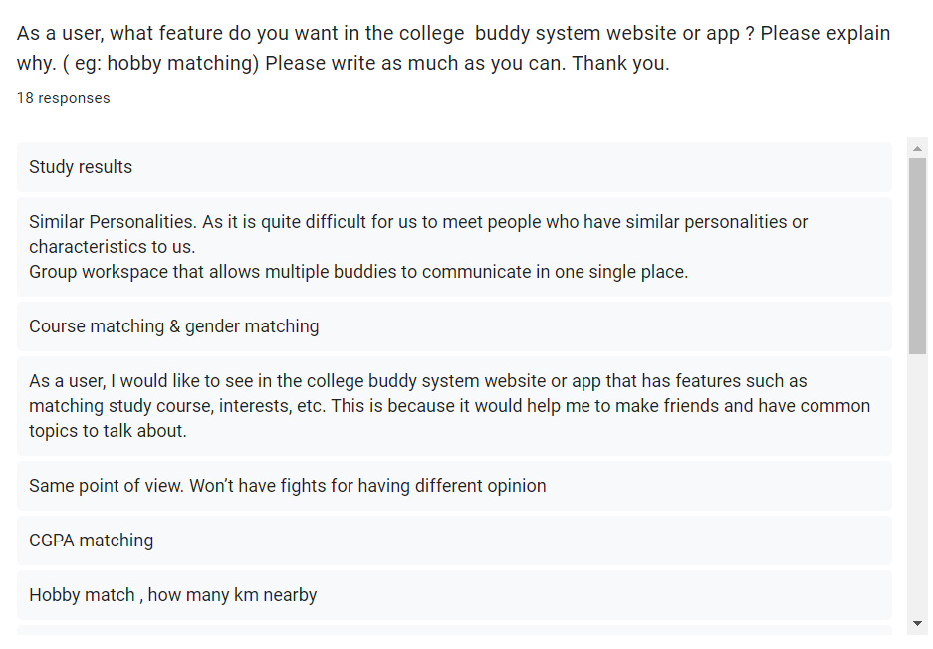

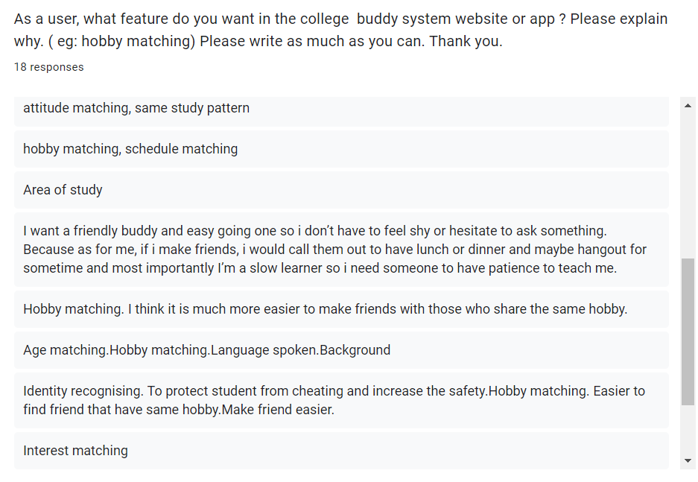

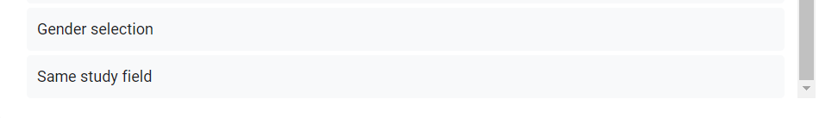

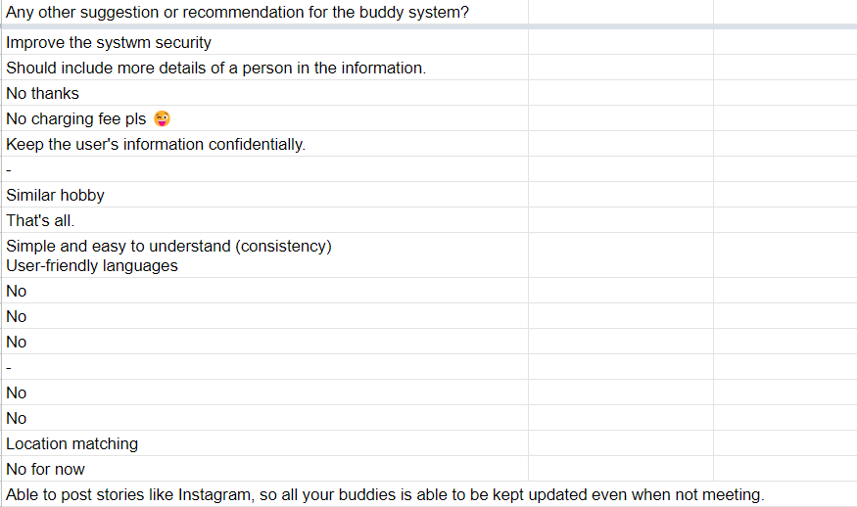

**User Story Mapping**

